FOOD MANAGEMENT SYSTEM

Software Requirements Specification

For <Subsystem or Feature>

Version <1.0>

Revision History

|  |  |  |  |
| --- | --- | --- | --- |
| **Date** | **Version** | **Description** | **Author** |
| 25/12/2021 | 1.0 | <details> | Nguyen Thu Trang |

Table of Contents

1. Introduction 4

1.1 Purpose 4

1.2 Scope 4

1.3 Definitions, Acronyms, and Abbreviations 4

1.4 References 4

1.5 Overview 4

2. Overall Description 5

2.1 Use-Case Model Survey 5

2.2 Assumptions and Dependencies 5

3. Specific Requirements 2

3.1 Use-Case Reports 2

3.2 Supplementary Requirements

3.2.1 Interface requirement 2

3.2.2 License 2

4. Supporting Information 2

Software Requirements Specification

# Introduction

Currently, ordering and getting a meal at the restaurant is currently done manually where the customers have to go to the restaurant to order, select the product and waiting for the cook to complete. This may become a waste of and it is inconvenient to procure product for the customers from remote areas. In addition, the employees of our restaurant may find difficulty in managing the product.

Therefore, we have decided to build a Product Management System. Customer will be using this scheme to order and buy the product, and the staff will easy to sell the product and update the information. The purpose of this document is to analyze and elaborate on the high-level needs and features of the Food Management System. It focuses on the capabilities and facilities provided by a restaurant.

## Purpose

The purpose of Software Requirements Specification document is to describe the external behavior of the Product Management System. Requirements Specification defines and describes the operations, interfaces, performance, and quality assurance requirements of the Product Management System. The document also describes the nonfunctional requirements such as the user interfaces. It also describes the design constraints that are to be considered when the system is to be designed, and other factors necessary to provide a complete and comprehensive description of the requirements for the software. The Supplementary Specification captures the complete software requirements for the system, or a portion of the system. Requirements described in this document are derived from the Vision Document prepared for the Product Management System**.**

## Scope

The Software Requirements Specification captures all the requirements in a single document. The Product Management Systemthat is to be built provides the restaurant’s customers and staff with product details, products online buying of and many other facilities.

## Definitions, Acronyms, and Abbreviations

## References

## Overview

This Requirements Specification will provide a detailed description of the Food Management System. This document includes a description of the specification, will provide the outline of the requirements, overview of the characteristics and constraints of the system.

# Overall Description

The overall description of our project can be stated as creating and managing the database, developing a friendly user interface to manipulate product management system the database.

## Use-Case Model Survey

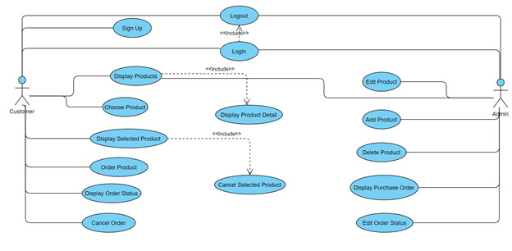

## Assumptions and Dependencies

### **Manage user**

Customer can log in, log out the system.

### **Order product**

After see all information about product which consist of name, price, image quantity, price, customer click in payment to complete the process of order.

***2.2.3 Choose product***

Customer can select one or more products.

***2.2.4 Management product***

Admin can add/ remove/ edit products in the system

***2.2.5 View product***

In here, admin and customer can view all product of restaurant

***2.2.6 Edit orders***

Customer can edit orders

***2.2.7 Edit product***

Customer can add/ remove/edit product which was selected

***2.2.8 Cancel orders***

Customer can cancel orders

***2.2.9 View orders***

Customer and employee of restaurant can view the orders

***2.2.10 View order status***

Admin can view the order status after customer ordered

# Specific Requirements

## Use-Case Reports

## Supplementary Requirements

***3.2.1 Interface requirement***

- Easy to use

-   Interface includes different tabs with title according to its function

***3.2.2 License***

License belongs to restaurant that Department of Hygiene and Product Safety Licensed.

# Supporting Information